**Why not pip freeze?**

* pip freeze only saves the packages that are installed with pip install in your environment.
* pip freeze saves all packages in the environment including those that you don’t use in your current project. (if you don’t have virtualenv)
* and sometimes you just need to create requirements.txt for a new project without installing modules.

I think pipreqs is more suitable for our project, because it just install the package according to the project not the environment.

pip install pipreqs

pipreqs --force (added all the package in the current project to the requirements.txt. AND if you already have requirements.txt, you can use –force to overwrite it)

pip install -r requirements.txt (install all the package in the requirements.txt)

(to use “pip freeze > requirements.txt”) added all the package in the current env to the requirements.txt

pip install chatterbot==1.0.4

pip install chatterbot-corpus

if Error, see blow

ERROR: Cannot uninstall 'PyYAML'. It is a distutils installed project and thus we cannot accurately determine which files belong to it which would lead to only a partial uninstall

pip install --ignore-installed PyYAML

change time.clock to time.time

If no error, go here,

pip install speechrecognition

if you use python 3.7, you need to install 2.7.1

pip install pyttsx3==2.71

pip install pytz

# pip install neuralintents, no need for now.

how to install pyaudio

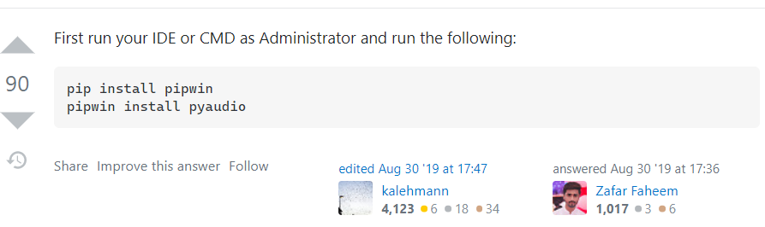

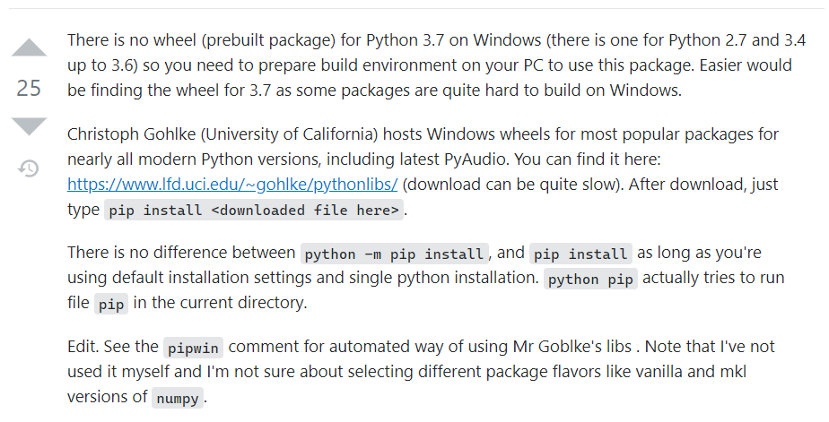

https://www.lfd.uci.edu/~gohlke/pythonlibs/

after install all package

run app.py file.

If you see this screen shoot, it means it works successfully!, then open the website.

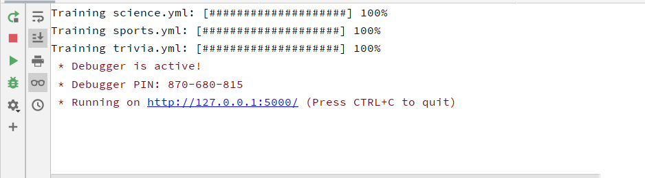



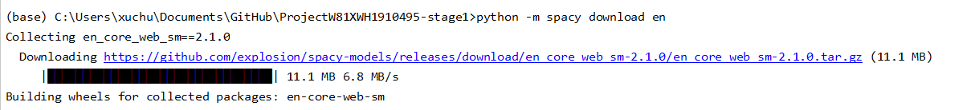

Some errors

If you can’t open the schema of database, you may need to download driver files and make you’re your database connected.

Right click database and click properties.

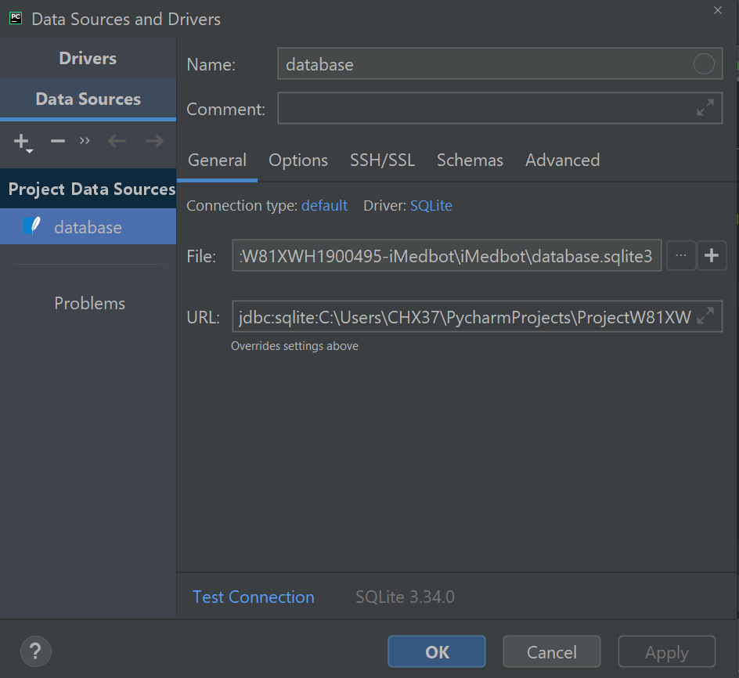

Error messages intalling iMedBot on Jiang’s remote desktop 2021.6.4





